Trust Questionnaire – 2018

Please ensure this questionnaire is completed, signed and included with your records

Client Name |  | Phone:
Balance Date | 31 March 2018 | Fax:
 |  | Email:

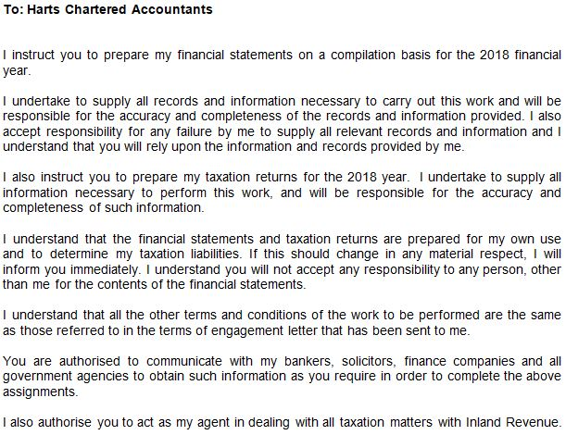

Signature Date _______________________

If sending this back by email, please type your name in above – otherwise sign it. By doing so, you are acknowledging
that you accept the above terms and conditions of the engagement.

Inland Revenue prefers to pay any refunds by direct credit. Would you please advise the bank account number

you would like any refunds deposited in to:

Account number: _____________________________________________

Records and Information Required: |  | Comments:
1. Trustees / Settlor
Please advise any changes in address and other circumstances | ☐
2. Gifting Programme
Please advise the date of gifts made to your trust during the financial year  Please attach details of the gifting documentation from your solicitor | ☐ | Date of gift ______________
3. Minutes / Resolutions / Memorandum of Wishes
Copies of any minutes, resolutions, or Memorandum of Wishes | ☐
4. Bank Statements
Copies of bank statements for all trust bank accounts  Details of all transactions or cheque and deposit books | ☐  ☐
5. Beneficiaries
Where expenses have been paid on behalf of a beneficiary please indicate which beneficiary the expense relates to. | ☐
6. New Zealand Investments
Copies of certificates for interest and dividends  Details of any sales, purchases and gifts of shares or other investments | ☐ ☐
7. Overseas Investments
There are new rules for the taxing of overseas investment including various methods of calculating your foreign investment income (FIF).  Please provide:  Copies of certificates for interest & dividends.  List all your overseas investments- include the cost, currency and date of purchase of those investments including foreign superannuation and life insurance schemes and property.  Dividend statements of any dividends received or shares issues in lieu of dividends.  There may be further information required once we have assessed what method of calculating your foreign investment income will apply. | ☐  ☐  ☐

8. Have you bought or sold any property this year? YES / NO
If yes, please supply details | ☐

9. Rental Income or Mixed Use Holiday Home
If applicable, please complete the separate questionnaires for each  property | ☐

10. Did you have any income from short term rentals, i.e. Airbnb YES / NO
If yes, please supply details | ☐
11. Other Income
Please provide details of any other income | ☐
12. Major Transactions
Please provide a list of any other major transactions that have occurred  during the financial year that affect the Trust. | ☐

