Non-Resident Questionnaire – 2018

Please ensure this questionnaire is completed, signed and included with your records
Client Name |  | Phone: | Work:  Mobile:  Home:
Balance Date | 31 March 2018 | Fax:
 |  | E-mail:

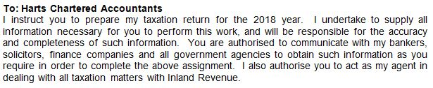

Signature Date _______________________

If sending this back by email, please type your name in above – otherwise sign it. By doing so, you are
acknowledging that you accept the above terms and conditions of the engagement.

Inland Revenue prefers to pay any refunds by direct credit. Would you please advise the bank account number you would like any refunds deposited in to:
Account number: ________________________________________

Records and Information Required |  |  | Comments

1. Wages YES / NO
Please provide us with the names of any organisations you have received the following from:  - Wages with PAYE deducted in New Zealand  If wages were received, please advise your date of arrival/departure in New Zealand.  In most cases Inland Revenue will have sent us these wages details direct however we do need to check all details have been included. | ☐  ☐

2. New Zealand Interest and Dividends YES / NO
Please supply the advice slips.  - For interest received, you should have an annual advice notice showing the withholding tax deducted. This may be on the bottom of your bank statement dated 31 March.  - If any dividends are taken as bonus shares, also include these advice slips. | ☐  ☐

3. Rental Income or Mixed Use Holiday Home YES / NO
If applicable, please complete separate questionnaires for each  property in New Zealand. | ☐

4. Partnerships, Trusts, Estates and Companies in New Zealand - YES / NO
Please supply details of income received. | ☐

5. Have you bought or sold any property this year? - YES / NO
If yes, please supply details | ☐

6. Did you have any income from short term rentals, i.e. Airbnb - YES / NO
If yes, please supply details. | ☐

7. Any Other Income / Deductions
- Attach details of any other income derived in New Zealand  - Look Through Company (LTC) – if you have been allocated a share of a loss other than from a company that we are aware of, please provide details | ☐  ☐

8. Student Loans
I have a student loan  I have made voluntary payments of $_______________ | ☐

