Estate Questionnaire – 2018

Please ensure this questionnaire is completed, signed and included with your records

Client Name |  | Phone:
Balance Date | 31 March 2018 | Fax:
 |  | E-mail:

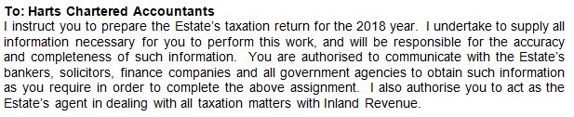

Signature Date ____________________________

If sending this back by email, please type your name in above – otherwise sign it. By doing so, you are acknowledging
that you accept the above terms and conditions of the engagement.

Inland Revenue prefers to pay any refunds by direct credit. Please advise the bank account number

you would like any refunds for the Estate deposited in to:

Account number: ________________________________________

Records and Information Required: |  | Comments:
1. Executors
Please advise any changes in address and other circumstances | ☐
2. New Zealand Investments
Copies of certificates for interest and dividends | ☐
3. Overseas Investments
There are new rules for the taxing of overseas investment including various methods of calculating foreign investment income (FIF).  Please provide:  Copies of certificates for interest and dividends.  A list all overseas investments - include the cost, currency and date of purchase of those investments including foreign superannuation and life insurance schemes and property  Dividend statements of any dividends received or shares issues in lieu of dividends  There may be further information required once we have assessed what method of calculating your foreign investment income will apply. | ☐  ☐  ☐
4. Rental Income or Mixed Use Holiday Home
If applicable, please complete the separate questionnaires for each  property in New Zealand | ☐
5. Other Income
Please provide details of any other income | ☐

