Company Rental Questionnaire – 2018

Please ensure this questionnaire is completed, signed and included with your records

Client Name |  | Phone:
Balance Date | 31 March 2018 | Fax:
 |  | E-mail:

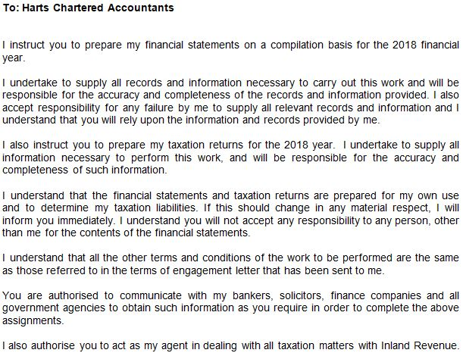

Signature Date ______________________

(if sending this back by email, please type your name in above – otherwise sign it. By doing so, you are acknowledging that you accept the above terms and conditions of the engagement)

Inland Revenue prefers to pay any refunds by direct credit. Would you please advise the

bank account number you would like any refunds deposited in to.

Account number: ________________________________________

Rental Property Questionnaire – 2018

1. Property Details
Address of rental property:  ___________________________________________________________ | If property was not rented for a full 12 months, please provide details of why it was vacant and the number of days vacant  ________________________________  ________________________________
Number of days the property was used privately (by you, your family or associated persons, even if rent was charged) during the period
Number of days the property was rented out for less than 80% of the market rate to persons not associated to you

2. Rental Income and Expenditure
Please supply bank statements clearly identifying and detailing all transactions that relate to the rental properties  OR  Please provide details of the following for each rental property. Use a separate sheet if necessary.  Income:  Total rent received $__________________  Expenses:  Rates $__________________  Insurance $__________________  Repairs and Maintenance (please attach details or invoices) $__________________  Mortgage interest (attach copy of loan summary/statements from bank) $__________________  Travel ________________km  Details of any other expense relating to rental property:  ________________________________________________ $__________________  _________________________________________________ $__________________  Please attach all relevant documentation, including property manager’s statements, and details of any assets purchased over $500 |  | ☐  ☐
3. Rental property sold, purchased or rental ceased during the financial year |  | ☐ Yes  ☐ No
If yes please provide the following:  - Solicitors settlement statement  - Sale and Purchase Agreement  - Loan details for property purchased  - A copy of the latest rateable valuation  - A list of chattels and their value for properties bought or sold during the year  - If ceased renting – date ceased ________________________ |  | ☐  ☐  ☐  ☐  ☐

Records and information required |  |  |  | Comments:
4. Investment Income
Do you have New Zealand investments?  Do you have overseas investments?  If yes, please provide all interest and dividend advices, and changes in investments | ☐☐
5. Expenses paid in Cash or from Personal Funds
Please provide a list if applicable. |  | ☐
6. Events /Contingencies
There have been events occurring after balance date that will have a financial effect on subsequent years.  Details :  ________________________________________________________________  There were contingencies at balance date, the outcome of which will be determined by the occurrence or non–occurrence of an event.  Details :  ________________________________________________________________ |  | ☐  ☐
7. Goods & Services Tax (GST) Returns
Are you GST registered?  If Yes, supply copies of Goods & Services Tax (GST) returns and  workpapers | ☐No  ☐ Yes
8. Changes in Company details
Please provide details of any changes in the following  - Shareholding  - Registered office  - Directors  - Shareholder address | ☐  ☐  ☐  ☐
9. Other Income
Please provide details of any other income | ☐
10. Home Office Expenses
If part of your home is set aside principally for use as an office/workshop/storage area, please provide the following details:
Address: ___________________________________________________

Business Area: ___________m²
Total Area: ________m²
Power $______________
Insurance (Building & Contents) $______________
Interest (House Mortgage) $______________
Rates $______________
Repairs & Maintenance $______________
Rent paid $____________
Other $______________
Total $______________

